Муниципальное казенное общеобразовательное учреждение «Алкадарская средняя общеобразовательная школа».

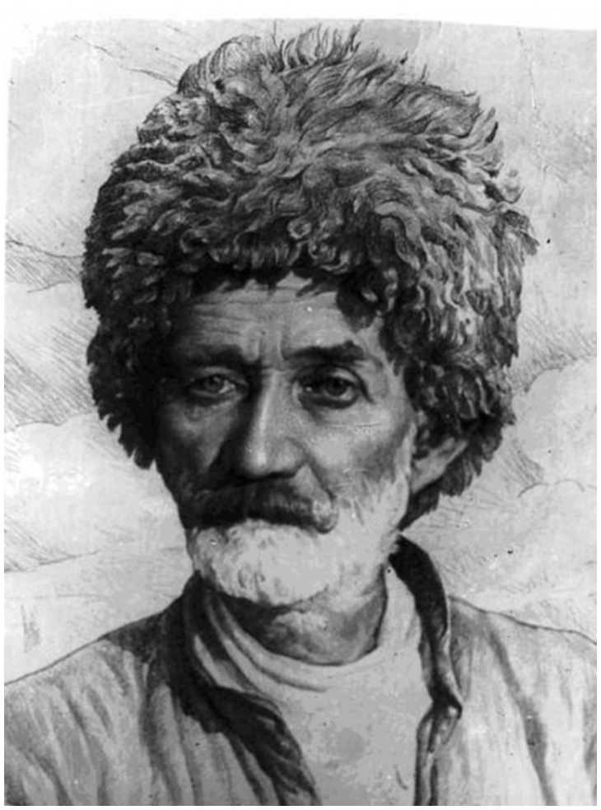
Project work on the English language on the topic:
"Lezgin poet-ashug Suleiman Stalsky: biography and creativity".

Prepared by the 10th grade student: R. M.Мurtuzaliyevа.
Project Manager an English teacher: Aslanbekova Z. Y.

Алкадар 2018 г.
The biography of Suleiman Stalsky, especially his childhood years, is full of tragic events. It is amazing how a boy who grew up in the most difficult conditions managed to keep in his heart the love for people. The biography of the national Dagestan poet and the founder of poetry in the Lezgian language shows how the kindness of the soul and sincerity help even the most modest person to gain recognition and touch the hearts of different people with his work. Stalsky's poetry is still the main literary reflection of the folk life of the Caucasian peoples at the turn of the 19th and 20th centuries. What kind of person was the poet Suleiman Stalsky?
Biography .
Suleiman Hasanbekov was born on may 18, 1869 in the Dagestan aul Ashaga-Stal, his parents were Lezgins living in poverty. The birth of the future poet was unusual: having quarreled on the eve of childbirth, Suleiman's father drove his pregnant wife out of the house, and the woman had to give birth in the barn. Barely alive after childbirth, the mother was not even allowed to the baby: the baby was nursed by a neighbor, and the unfortunate woman had to leave the house. In a short time she died at some villagers who sheltered her, never having seen her son. Apparently, the insult to the mother of the boy my father was very strong, as he continued to vent it on the son. From the age of four, Suleiman was busy with housework, and when his father married for the second time, and did become something like a servant, "errand boy" .
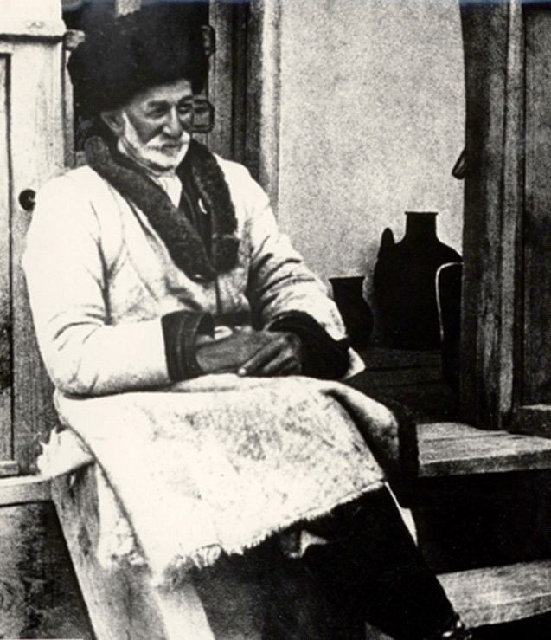
At the age of eleven, Suleiman became an orphan. From the age of 13 he was forced to become a hired worker, farmhand in Derbent, Samarkand, Ganja and Baku. The poet often recalled that all his youth was spent in his work, but one day he woke up and realized that he was already thirty years old. Soon Suleiman married, his chosen one was the daughter of a devourer from the neighboring village of Orta-Stal.
The first creativity.
All this time, busy with work and the arrangement of his life, Suleiman Hasanbekov did not even think about poetry. But once in the village where he lived with his wife, came Lezgin poet-Troubadour. Ashugs are the Caucasian version of a minstrel or Troubadour, that is, wandering singers accompanying themselves on some simple instruments and performing folk songs. For Suleiman, ashug's speech was a real revelation: he suddenly realized that he himself could Express his thoughts in this way. That same evening he composed his first poems in Azerbaijani, later telling them in both Dagestan and Lezgian. The novice poet had a poor command of writing, and therefore composed poems and songs collected in memory, telling them to friends and neighbors.
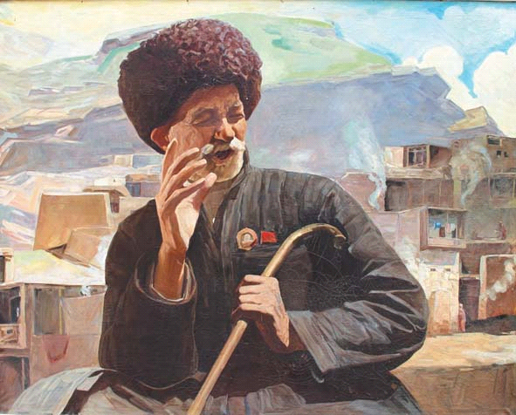
The first real poems of Suleiman Stalsky is considered to be "the Nightingale", composed in 1900.
On an Apple-tree,
in foliage dense,
sings perpetual Nightingale,
As is pure, as gentle voice your,
About inspired Nightingale!
Eat from the world atresias,
Carefree, happy you are now.
Oh, you don't care about us, Blessed Nightingale!
You despise people ready Ringing in the garden on a hundred frets.
But, coward, you run from the cold.
Shame on you haughty Nightingale!
Wait where are you going?
The fears come on!
Tell me how you lived.
Maybe now the time has come?
Be Frank Nightingale.
But in this winter you not roads,
Was winter day to you not strict.
All the colors you saved your,
My incomparable Nightingale.
A hawk rose...
Hide away In the deep shadow,
in the forest night!
Can I help You, my bold Nightingale?
You do not know the end of the ringing,
you do not know the calm,
you Are like a gramophone,
the Beauty of the universe Nightingale!
Carelessness frisky forget!
Find the nest!
Stay with me!
And the sounds of Suleiman in the chest to
Pour, priceless Nightingale!
Soon the work of the novice poet spread throughout Dagestan, poems were passed from mouth to mouth. At the same time, his pseudonym came to Suleiman: not knowing his surname, people called him by his place of birth: first Ashaga-Stalsky, and then just Stalsky. Since 1909, the biography of Suleiman Stalsky mentions his competitions with the famous ashugs, in which he never hit his face in the dirt.
Soviet period.
After the revolution, the talented Dagestan poet, praising freedom and ridiculing slavery and the rich, drew serious attention. All the joy of the common people about the change of power was expressed in simple and sincere poems of Suleiman stalsky. Important for the poet was the speech at the all-Union livestock Congress: Joseph Stalin himself listened to his poems from the Presidium. The translation of poetry from the Lezgin language into Russian began to appear in different Newspapers, mostly in "Pravda" and "Izvestia". Already in 1927 in Moscow was printed "Collection of Lezgin poets." It includes poems by Suleiman Stalsky. His work was highly appreciated by Russian-speaking poets of the time for genuine sincerity and Caucasian ability to play with words.
In 1934, from Dagestan, Suleiman Stalsky was chosen as a delegate to the first all-Union Congress of writers. Maxim Gorky, who praised the work of Stalsky, called him " Homer of the 20th century." Gorky and Stalsky in the photo below.
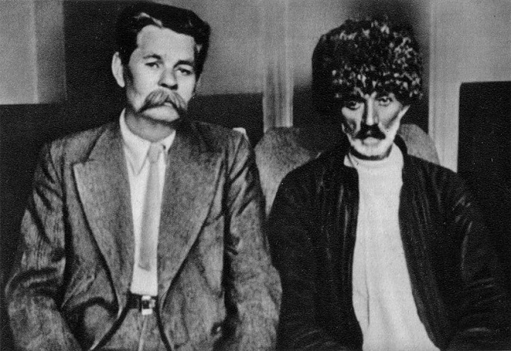
Memory.
Suleiman Stalsky died on November 23, 1937 in Makhachkala (Dagestan). In memory of the national poet in the year of his death, the Dagestan village of Samurkent was renamed into Stalskoye, the name is preserved to this day. in 1969, the Kasumentsky district of Dagestan was renamed Suleiman-Stalsky district - this event was timed to the centenary of the poet's birth, in the same year a commemorative stamp with a portrait of Stalsky was issued. In addition, streets in Dagestan, Rostov-on-don, Omsk, Novorossiysk are named after the poet, the Republican prize in the field of literature and the State Lezginsky musical theater are Stalskimi. In Makhachkala there is a memorial bust of stalsky.
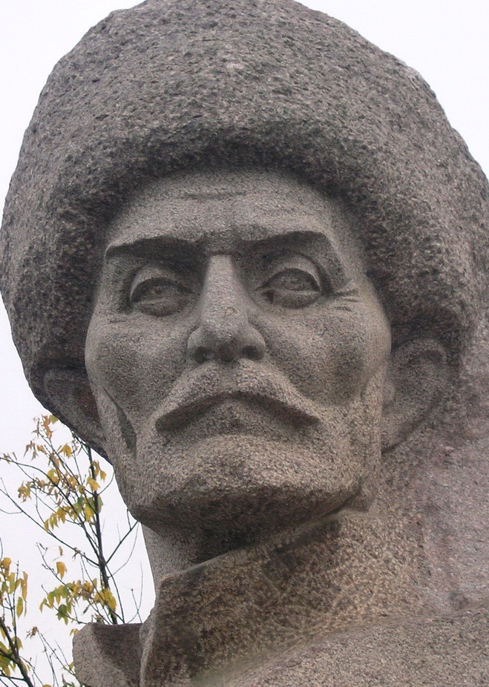
Suleiman Stalsky.
Museum of Suleiman Stalsky.
